


College Code: 9623

College Name: Amrita College of Engineering and Technology
Department: Artificial Intelligence and Data Science
Student NM-ID: autad0001
Roll number: 962323243001

Completed the project named as: Phase 5 : Project Demonstration and documentation

Submitted by: Aarthibala .R

Phase 5 : : Project Demonstration and documentation

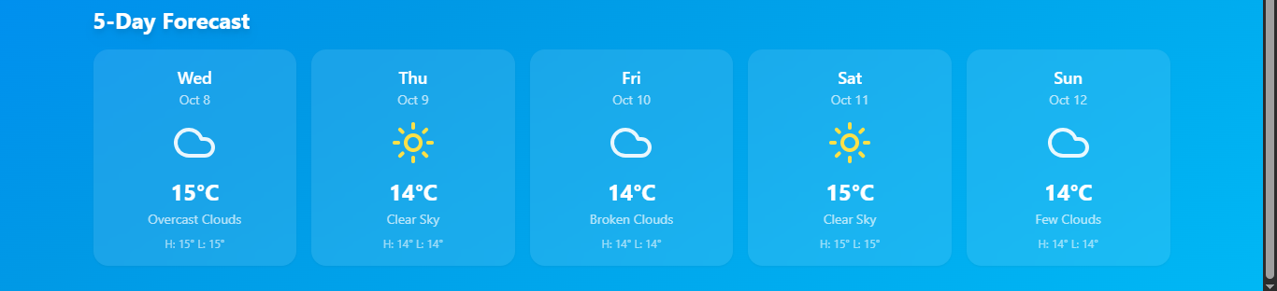
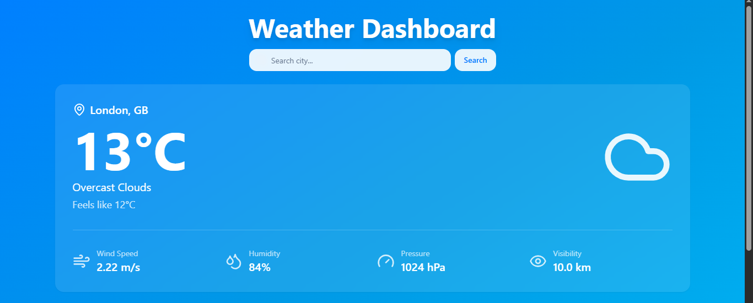

The final demonstration will showcase the complete functionality of the Live Weather Dashboard in a real-time environment.
- User Interface Overview:
Display of the homepage with a clean and interactive UI that allows users to search for cities or locations.
- Core Functionalities:
  - Real-time weather data display (Temperature, Humidity, Wind Speed, Weather Condition, etc.).
  - Integration with live weather APIs (e.g., OpenWeatherMap API).
  - Automatic location detection using geolocation APIs.
  - Dynamic icons and backgrounds based on weather conditions (e.g., rain, sunny, cloudy).
  - 5-day weather forecast section.
  - Error handling for invalid cities or network issues.

- Technology Stack Used:
  - Frontend: HTML, CSS, JavaScript / React
  - Backend (if any): Node.js / Express (for API routing)
  - API Used: OpenWeatherMap API (or similar)
  - Deployment Platform: GitHub Pages / Netlify / Vercel

- Demo Flow:
  - Launch the web app.
  - User enters a city name.
  - App fetches and displays live weather information.
  - User views additional weather details and forecast.
  - System updates automatically based on location or refresh.

- Features:

* Real-time weather updates
* 5-day forecast
* Location-based search
* Dynamic UI themes

Our project’s deployment link:

https://68e3fecb145eb0085810a6f2--liveweather2k25.netlify.app/

Final Outcome:

The Live Weather Dashboard will serve as a practical example of integrating APIs, frontend design, and responsive web development. This phase validates the end-to-end functionality, documentation, and deployment readiness of the project.

